**2018 Stock Data-Solutions**

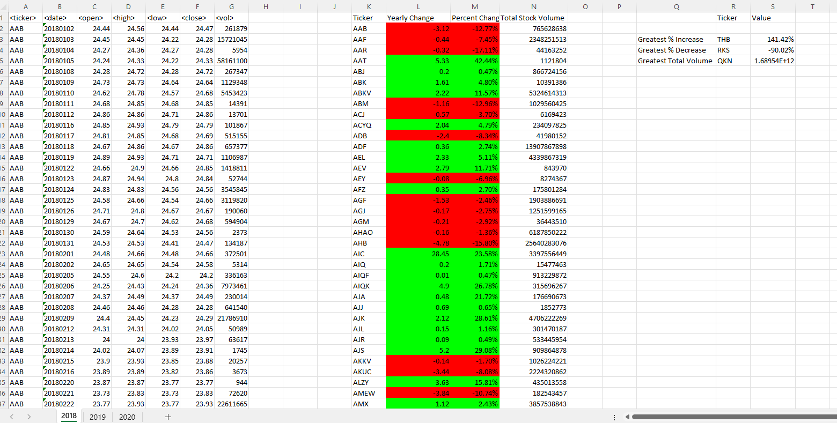

**2019 Stock Data-Solutions**

**2020 Stock Data-Solutions**

